**VEHICLE DETECTION**

Vehicle Detection using Deep Learning and YOLO Algorithm

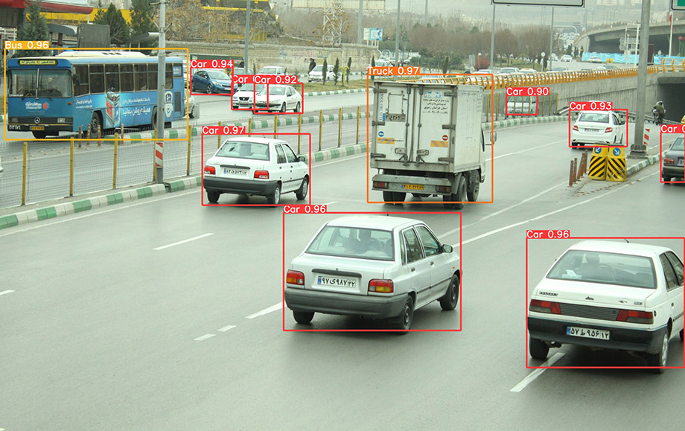

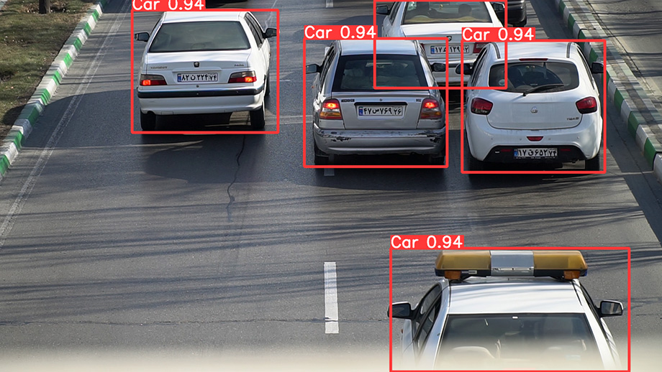

**DATASET:**

Take or find vehicle images to create a special data set for

fine-tuning.

Train: 70%

Validation: 20%

Test: 10%

Config dataset.yaml file for the address and information of your dataset.

It contains paths for dataset, training Set, validation set, test set and array of classes(Car, Motorcycle, Truck, Bus, Bicycle).

**COMMANDS:**

Execute these commands before running the project.

1. cd Vehicle-Detection (this will change the directory to the project directory)
2. pip install -r requirements.txt (this command will install all required packages)
3. pip install wandb (to have map, loss, confusion matrix and other matrices, sign in <http://www.wandb.ai>).

**TRAIN:**

Fine training on a pre-defined model of yolov5.

Run this command:

python train.py --img 640 --batch 16 --epochs 50 --data dataset.yaml --weights yolov5m.pt

**TEST:**

After train, gives you weights of train and you should use them for test.

Run this command:

python detect.py --weights runs/train/exp12/weights/best.pt --source test_images/imtest13.JPG